2018-2019 Education Year.........................Secondary School The Second Term The Second Written Exam For The Fifth Graders

Choose the Correct answer 25 X 4=100 points

Name: Surname: Number: Class: Date:

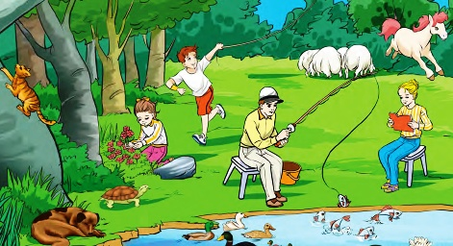

1-Verilen resme göre aşağıdakilerden hangisini **söyleyebiliriz?**

1. The woman is fishing.
2. The man is reading a book.
3. The girl is picking flowers.
4. The dog is swimming.

2- I am a small animal, I help people and I bark. I am a ………………………

1. cat c) horse
2. cow d) dog

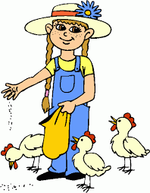

3-

1. She is climbing the tree.
2. She is collecting the eggs.
3. She is feeding the chickens.
4. She is sleeping.

4- Aşağıda verilen resim anlam eşleştirmelerinden hangisi **yanlıştır?**

1. c)

Rabbit Puppy

1. d)

Kitten Duck



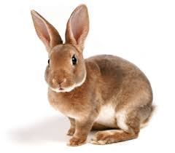

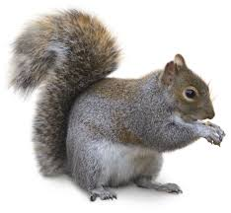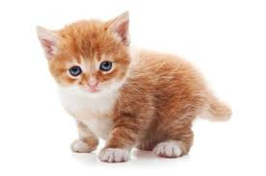

5- Sam:………………………………………?

Martin: I like table tennis.

1. Do you play table tennis
2. Which sports do you like
3. Can you play table tennis
4. What are you doing

Ahmet Haşim GARBETOĞLU [www.okuling.com](http://www.okuling.com) İngilizce Eğitim Materyalleri [www.ahingilizce.com](http://www.ahingilizce.com) İngilizce Eğitim Sitesi

6- What is the vet doing?

She is……………………..

1. examining the dog.
2. sleeping under the tree.
3. playing with the ball.
4. running in the garden.



|  |  |  |  |  |
| --- | --- | --- | --- | --- |
|  | cycling | skiing | jogging | camping |
| Mehmet | √ | X | √ | √ |
| Can | √ | √ | X | √ |
| Zehra | X | X | √ | X |
| Meryem | √ | X | √ | X |

7- Tabloya göre aşağıdakilerden hangisini doğrudur?

1. Mehmet doesn’t like cycling.
2. Meryem likes jogging.
3. Can doesn’t like camping.
4. Zehra likes skiing.

8- Verilen karşılıklı konuşmayı en iyi şekilde tamamlayan ifadeyi bulun

Medine: Let’s play chess.

Hatice:……….. I love chess.

1. Great idea c) I’m afraid, I can’t
2. No, I feel tired d) Sorry, not now

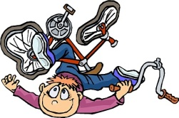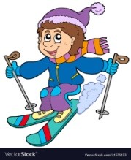

9- Verilen görselleri en iyi anlatan seçeneği işaretleyin.

1. I can ride a bike.
2. I can’t ski.
3. I can’t ride a bike but I can ski.
4. I can ski and I can’t read.

10- It is a………………….

1. candle
2. gift
3. invitation card
4. present



11- Aşağıda verilen Mevsim – Ay eşleştirmelerinden hagisi **yanlıştır?**

1. c)

1. d)

Winter

January

February

Summer

July

August

Spring

March

April

Autumn

November

December

12- Elvan: …………………?

Kemal: It is in May

1. When is your birthday?
2. What do you like?
3. What time is it?
4. What is your nationality?

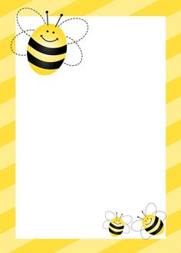

Please Join my birthday party

Jack

Place: Our Cafe

Date: Saturday

Time: 13:00

13- Davetiyede aşağıda verilen sorulardan hangisinin cevabı **yoktur?**

1. When is the party?
2. How old is Jack?
3. Where is the party?
4. What time does the party start?

14- Boş bırakılan yeri verilenlerden hangisiyle **tamamlayamayız?**

Cartoons are my favorite because they are……………

1. great c) exciting
2. funny d) boring



15- He has………………….

1. sore throat
2. cough
3. the measles
4. fever

Ahmet Haşim GARBETOĞLU [www.okuling.com](http://www.okuling.com) İngilizce Eğitim Materyalleri [www.ahingilizce.com](http://www.ahingilizce.com) İngilizce Eğitim Sitesi

16- He is ……………….

1. strong
2. honest
3. evil
4. helpful

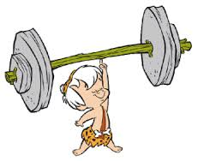

17-Aşağıda verilenlerden hangisi sağlıklı yaşam için yapmamız gerekenlerden biridir?

1. We should eat chocolate.
2. We should brush our teeth.
3. We should drink coke.
4. We should eat candies.

18- Sena has a shower every day.

1. c)
2. d)

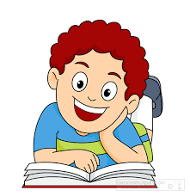

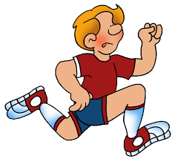

19- It is…………………..

1. half past two
2. two
3. ten past two
4. It is a quarter past two



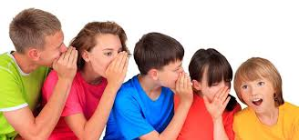

20-

…………………. is my favorite game.

1. Chinese whisper c) Blind man’s buff
2. Dodgeball d) Hopscotch