2018-2019 Education Year.........................Secondary School The Second Term The Second Written Exam For The Seventh Graders

Choose the Correct answer 25 X 4=100 points

Name: Surname: Number: Class: Date:

1-Aşağıda verilen eşleştirmelerden hangisi yanlıştır?

a) c)

Air pollution Plant a tree

b) d)

Recycle Deforestation

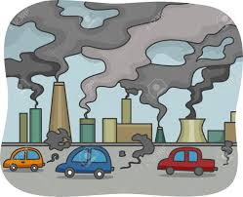

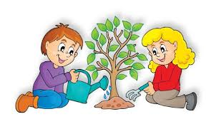

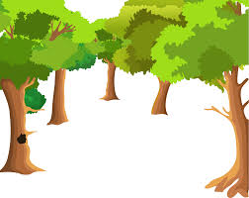

2-Boşluğa uygun düşen ifadeyi işaretleyin.

Farmers shouldn’t use too many……………..

1. pesticides c) eco-friendly bags
2. wind energy d) solar energy

3-Daha güzel bir çevre için aşağıda verilenlerden hangisini yapmamalıyız?

1. We must recycle paper, glass and metals.
2. We shouldn’t throw rubbish into the lakes, rivers or sea.
3. We must use poisonous chemicals.
4. We shouldn’ cut down trees.
5. I b) II c)III d)I

4-I feel ill and I want to go to a……………….. to buy some medicine.

a) chemist’s c)greengrocer’s

b) movie theatre d) bank

5-You want to talk to the mayor, Where do you go?

a) Coffee shop c)Bakery

b) Municipality d)Chemist’s

6-Last week I was at the at the amusement park. I had a great time there.

a) c)

b) d)





Ahmet Haşim GARBETOĞLU [www.okuling.com](http://www.okuling.com) İngilizce Eğitim Materyalleri [www.ahingilizce.com](http://www.ahingilizce.com) İngilizce Eğitim Sitesi

7- Ali: What is your dream for the future?

Tom: ……………………………………

1. I like watching TV.
2. I bought a car yesterday.
3. I will live in a big city.
4. I have a cat and a dog.

8- Tim: What is your brother’s dream job?

Harry: ……………………………………

1. He is a vet now.
2. He was a teacher ten years ago.
3. He will be an architect.
4. He is sleeping now.

9- Ali: ………………………………………?

Tom: I will run my own business.

1. What will you do in your 30s.
2. Would you like to c oto my birthday party
3. Where did you go yesterday
4. What did you do two days ago

10 ve 11. Soruarı aşağıda verilen davetiyeye göre cevaplayın.

Hi Alfred

We are going to have a costume party. We’re having the party at home. It is on Saturday at 7 p.m. Sam, Amy and Jack are going to join the party. Would you like to join us? I’m sure you’re going to have great fun with us. I hope you can come.

Mert

10-When is the party?

1. Amy and Jack
2. It is on Saturday.
3. It is a costume party.
4. They will join the party.

11- Where is the party?

1. At Mert’s house
2. At 7 p.m
3. Costume party
4. Alfred won’t jin the party.



12-Aşağıda verilen ifadede hangi Televizyon programından bahsedilmemiştir.

“I like watching documentaries, the news and cartoons”

1. c)

1. d)



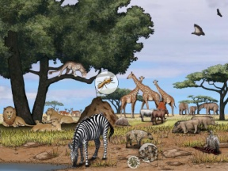

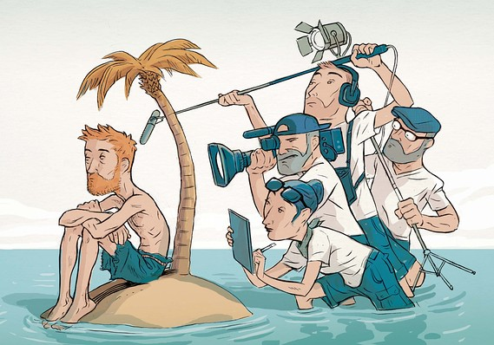

13- Tina:…………………………………….?

Sena: It is informative. I can learn many things while answering the questions.

1. How often do you watch quiz show
2. What is your favorite TV Programme
3. Why do you like quiz show
4. When did you last watch quiz show

14- I am a reptile. I am poisonous. I am a carnivore.

I am a …………………..

1. crocodile c) rhino
2. squirrel d) snake

Tigers are larger than all other wild cats. They can weigh up to 300 kg and measure up to 3.3 m.They are big and heavy. They are carnivores. They usually hunt alone at night.They have black and white stripes.They use their stripes as camouflage while hunting.

15- Verilen metinde aşağıdaki sorulardan hangisinin cevabı yoktur?

1. When do tigers usually hunt?
2. How many tigers are there in the world?
3. How much do tigers weigh?
4. How do tigers use their stripes

16- Ali studied very hard, He…….. successful student when he………. a student.

1. is / is c) is / was
2. was / was d) was / is

Ahmet Haşim GARBETOĞLU [www.okuling.com](http://www.okuling.com) İngilizce Eğitim Materyalleri [www.ahingilizce.com](http://www.ahingilizce.com) İngilizce Eğitim Sitesi

Nicola Tesla was an important inventor and physicist. He was born in Smiljan. He wanted to be an engineer. He studied a lot and learned many languages to read more about engineering. In 1884,he moved to the USA and worked With Thomas Edison.

17- Verilen metinde aşağıdaki sorulardan hangisinin cevabı yoktur?

1. When was Nicola Tesla born?
2. When did Thomas Edison move to the USA?
3. Why did Nicola Tesla learn many languages?
4. Whera was Nicola Tesla born?

18-Rose:………………………………………?

Martin: Twice a week.

1. What did you do yesterday
2. Which sports do you want to join
3. How often do you do sports
4. I don’t enjoy doing sports, what about you

Hello, I am John. I am 13 years old. Today is the first day at my new school. I don’t have any friends here. I help people and I never tell lies so I will make new friends easily.

19 – John için aşağıda verilenlerden hangisini **söyleyemeyiz?**

1. He is honest.
2. He is thoughtful
3. He is outgoing.
4. He is forgetful.

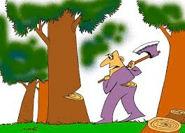

20- Yukarıda verilen görselde anlatılmak istenen aşağıdakilerden hangisidir?

1. We mustn’t waste water.
2. We mustn’t pollute the environment.
3. We mustn’t destroy forests.
4. We must use renewable energy sources.